Name: Pranali Sonawane
Subject: CCNA
Date: 11-11-2025
Lab – Router Information Protocol(RIP):
First, we have taken three routers, two switches.The routers are connected to each other using crossover cable.
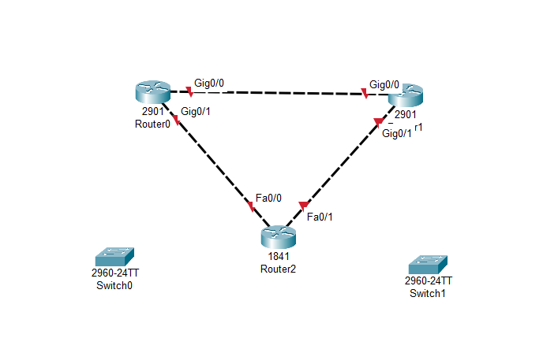
Open Router 0 – CLI prompt then type following commands
Router>enable
Router#configure terminal
Router(config)# interface Gig0/0
Router(config-if)# ip address 10.0.0.1 255.0.0.0
Router(config-if)#no sh
Router(config)#exit
Router(config)# interface Gig0/1
Router(config-if)# ip address 20.0.0.1 255.0.0.0
Router(config-if)#no sh
Router(config)#exit

Router(config)# show ip route
Router(config)#router rip
Router(config-router)#version 2
Router(config-router)#network 10.0.0.0
Router(config-router)#network 20.0.0.0
Router(config-router)#exit
Router(config)#exit
Router(config)# show ip route

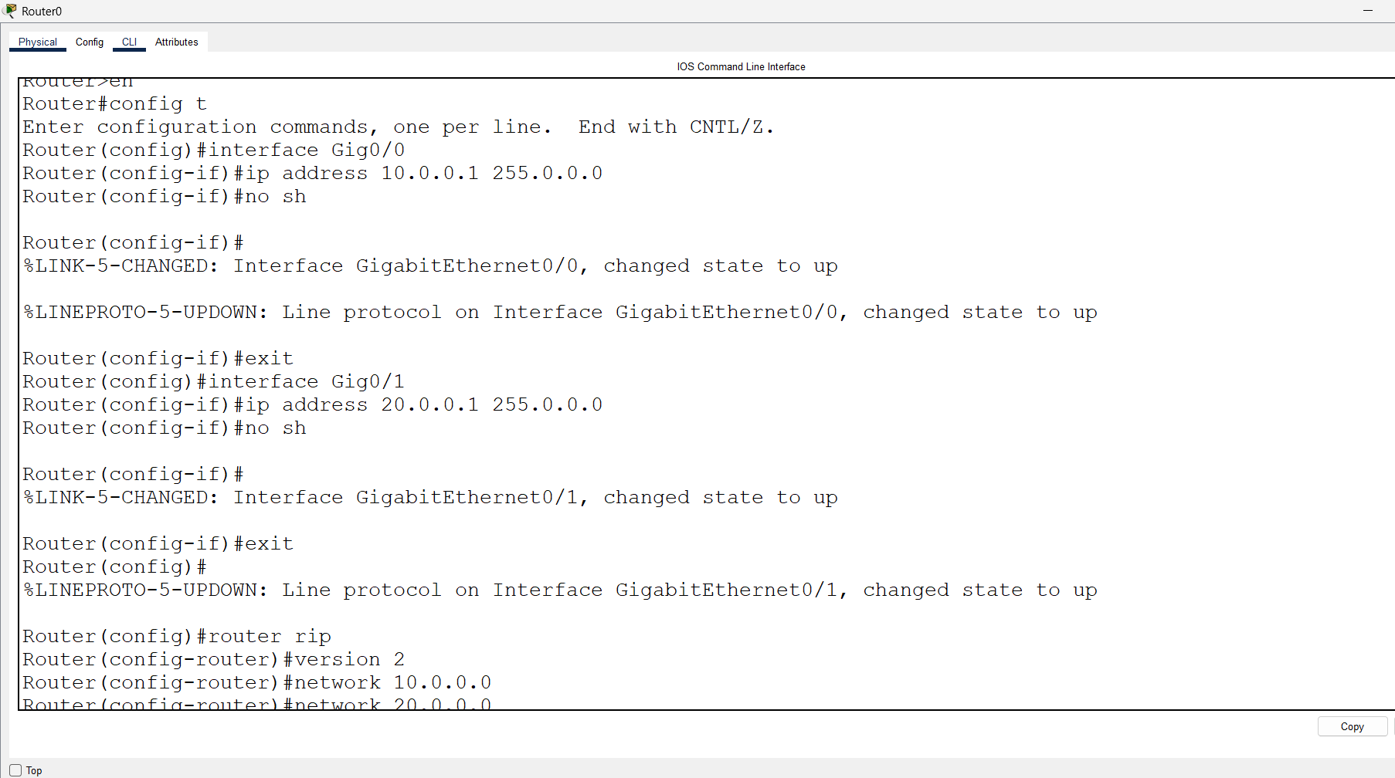
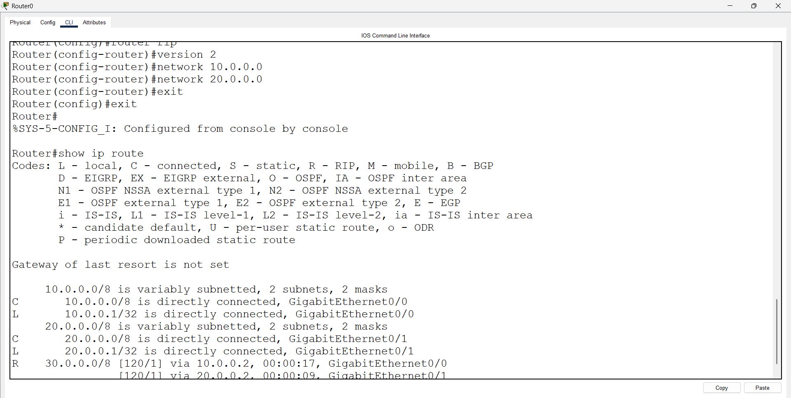
Open Router 1 – CLI prompt then type following commands
Router>enable
Router#configure terminal
Router(config)# interface Gig0/0
Router(config-if)# ip address 10.0.0.2 255.0.0.0
Router(config-if)#no sh
Router(config)#exit
Router(config)# interface Gig0/1
Router(config-if)# ip address 30.0.0.1 255.0.0.0
Router(config-if)#no sh
Router(config)#exit

Router(config)# show ip route
Router(config)#router rip
Router(config-router)#version 2
Router(config-router)#network 30.0.0.0
Router(config-router)#network 10.0.0.0
Router(config-router)#exit
Router(config)#exit
Router(config)# show ip route

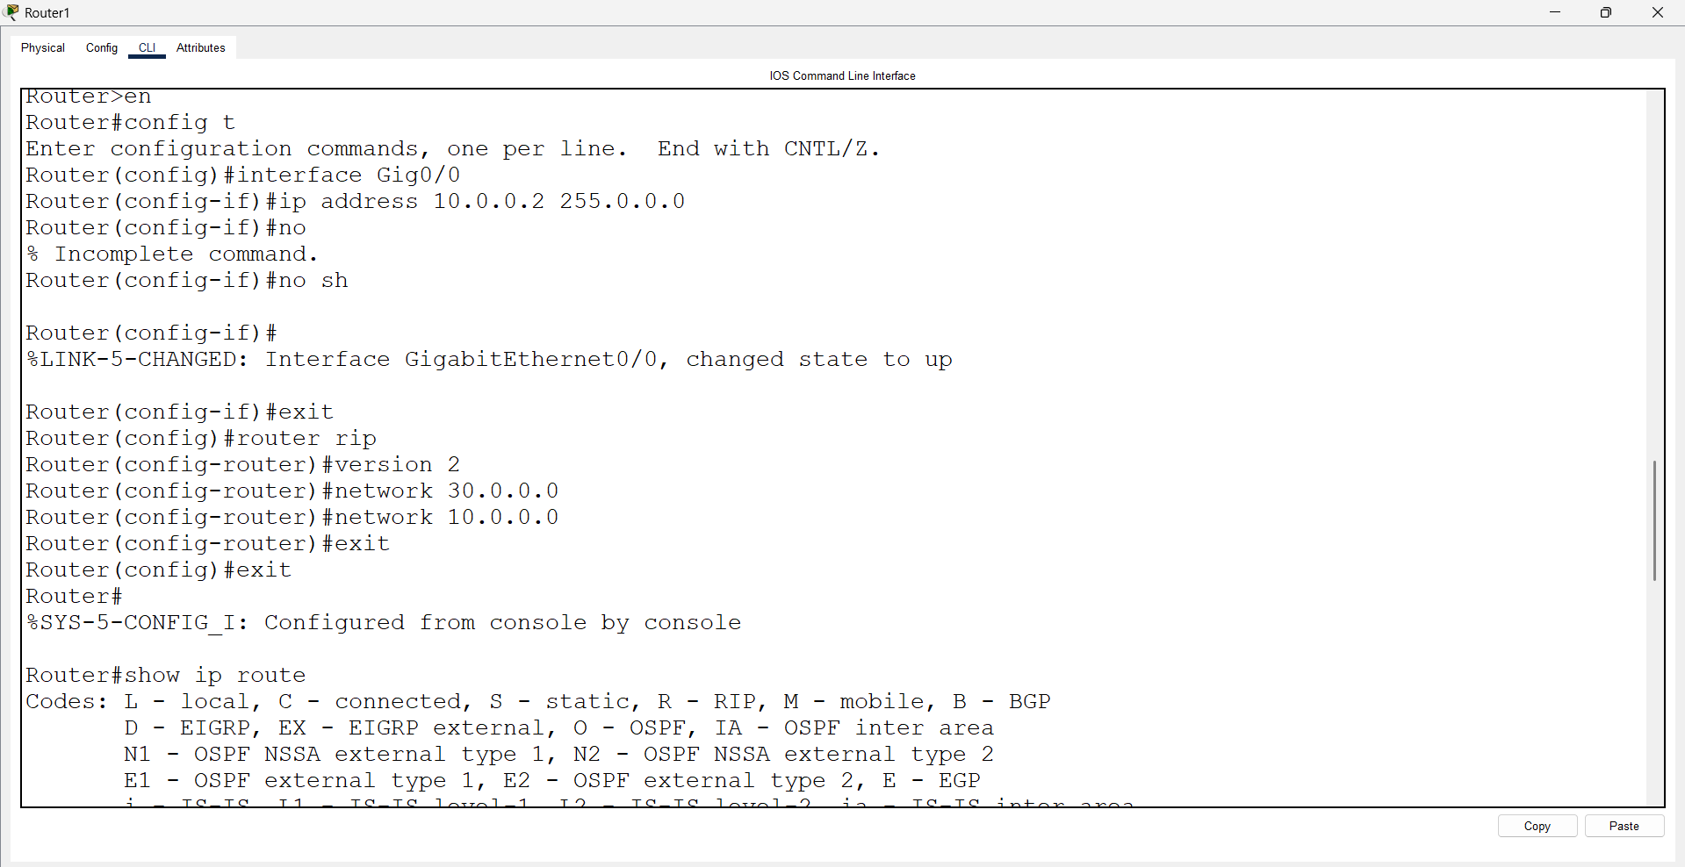
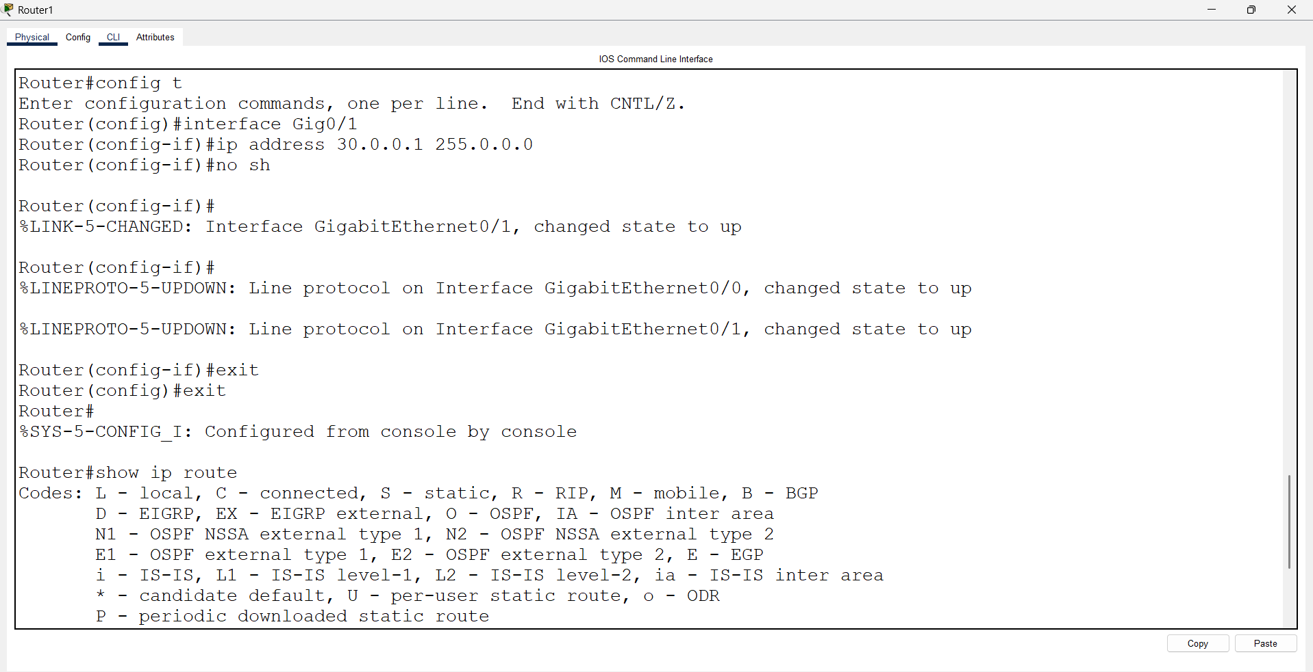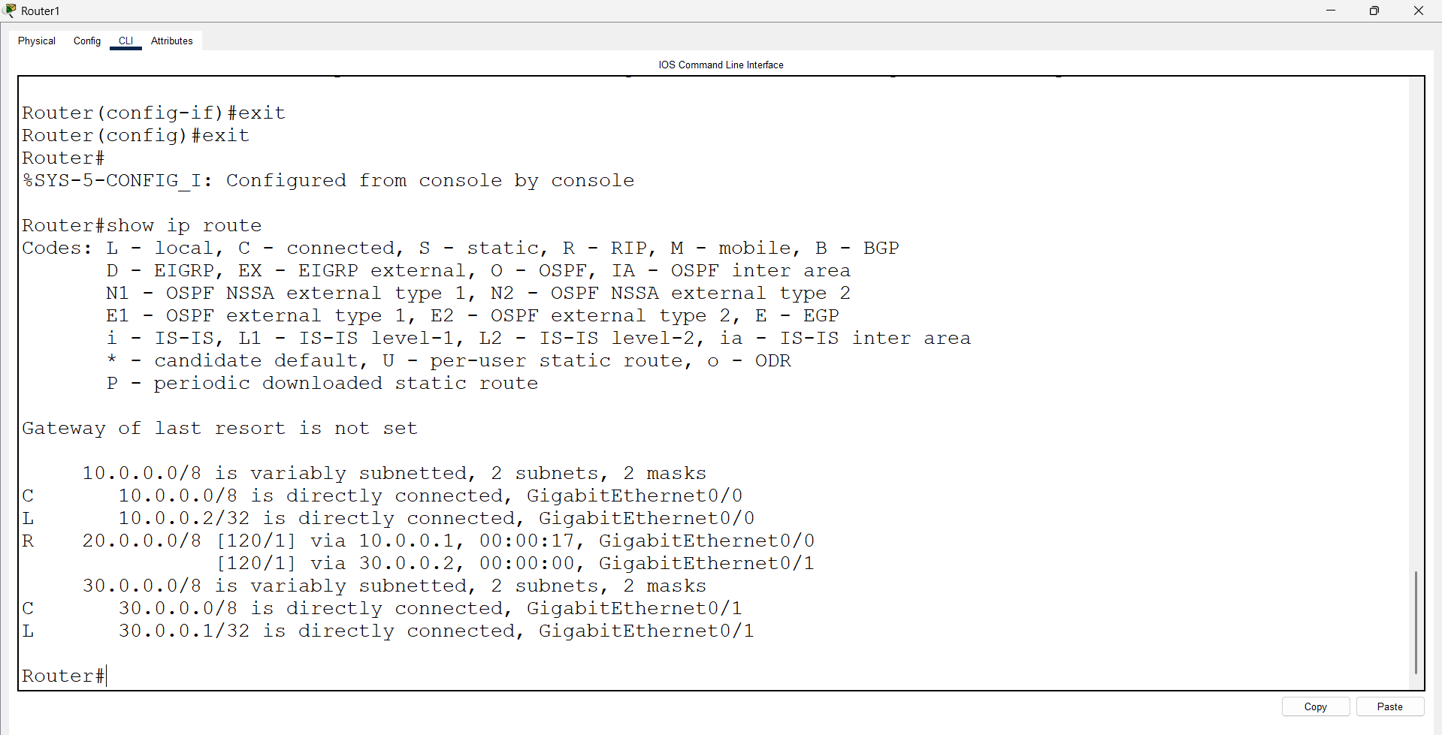

Open Router 2 – CLI prompt then type following commands
Router>enable
Router#configure terminal
Router(config)# interface fa0/0
Router(config-if)# ip address 20.0.0.2 255.0.0.0
Router(config-if)#no sh
Router(config)#exit
Router(config)# interface fa0/1
Router(config-if)# ip address 30.0.0.2 255.0.0.0
Router(config-if)#no sh
Router(config)#exit

Router(config)# show ip route
Router(config)#router rip
Router(config-router)#version 2
Router(config-router)#network 20.0.0.0
Router(config-router)#network 30.0.0.0
Router(config-router)#exit
Router(config)#exit
Router(config)# show ip route

